Choose one of the main characters from the novel. You will be creating a Facebook Profile and Wall for this character. Using the templates you will fill out relevant information, create pictures and have others write on his/her wall. The following information should be included:

- Picture or icon for character – what do you imagine the main character looks like? You may draw a picture or use one from the internet (different than the cover, use your imagination) /2 marks

- Facebook Profile- fill in the character’s information such as (birthday, hometown, relationship status, sex, birthday, hometown, favorites….) /8 marks
(copy and paste into paint or photoshop to edit and add in information)
Points deducted if missing any of the above, plus:
-Neatness (if it’s too sloppy to read, no credit for that item)
-Effort -Does not relate to the character or reading assignment

- Minimum of one status update/post per chapter (Facebook limits status updates to 420 characters) – these updates must reflect what you believe was important in that chapter. These posts may be from the character you are focussing on, or from a friends/other characters in the novel. /10 marks

Note-Each status update should summarize the most important thing that happened to that character (or what that character thinks is the most important information to share). For example, if someone close to the character dies and you write for your update: “Couldn’t find a thing to wear today! Guess I must go shopping.” Chances are you will get a zero, because even if a character is that self-centered, they would probably include something like: “Have to go to Bob’s funeral today…what in the world am I going to wear?? Guess I have to go shopping!”

-Points deducted if missing any chapters, plus: -Not relating to the chapter or character -Spelling/grammar mistakes (that are unintentional)

- Two advertisements (for fictional businesses relating to the novel) – create 2 advertisements from businesses that were mentioned in the novel. /4 marks

- Four or more other characters they are “friends” with- who are the other characters from the novel that the character would be friends with. /4 marks

- Neatness-overall effort /4 marks

Total /32 marks

Copy and paste these into paint, photoshop to edit and add in information.
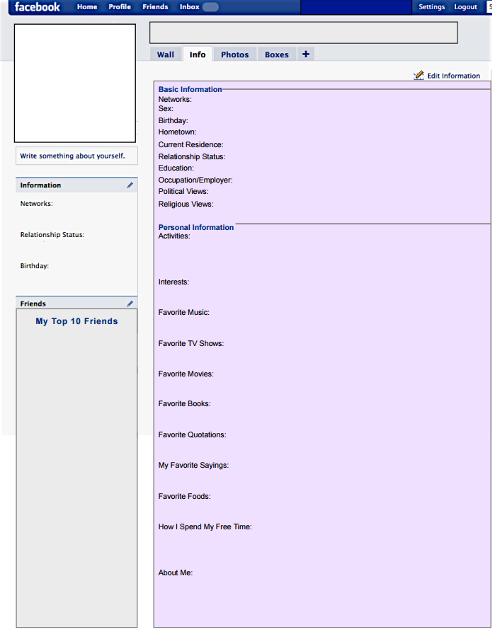
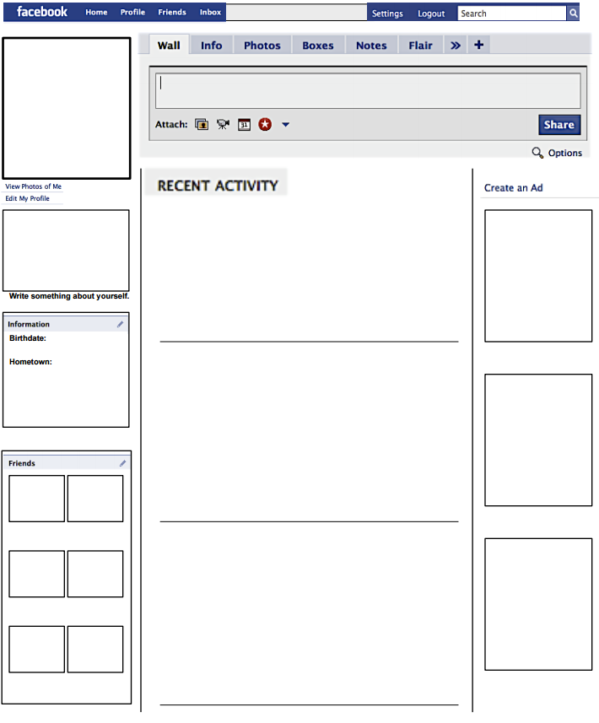
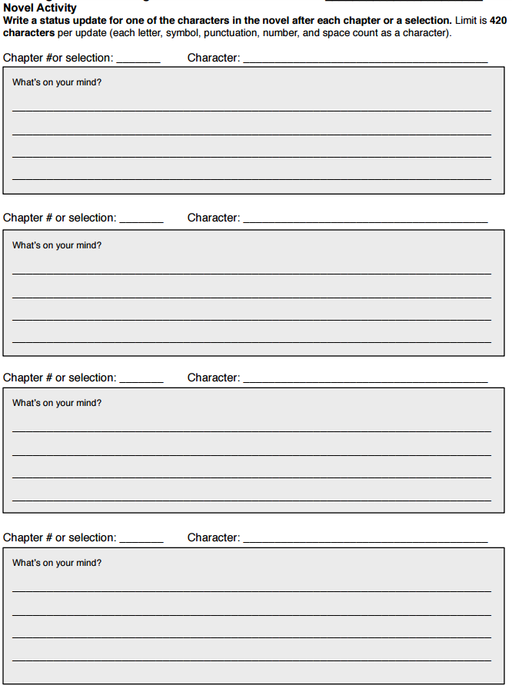
Use these to create your rough copies of the status updates:

